Flappy Patastrato

Intro
As it is foretold, once in a generation, a Patastrato is born with wings. They are the chosen one that can travel through the vines of death and escape the secluded valley where Patastratos are confined.
As the only Patastrato with wings, unfortunately, there is nobody to teach them how to fly, and they just struggle flapping around in a futile attempt to hold a stable flight. There are no manuals either, as Patastratos never developed a written language, or a language of any sort.
But Patastratos are know for their persistence -some would say stubbornness-, and for their inability to perceive danger. So here goes nothing, our winged hero will try their best to escape.
Come to think of it, the inability to perceive danger might be why the Patastratos only survived in the secluded valley where there are no dangers. Why do they want to get out anyway? Good question. In addition to all their other attributes, they have an insatiable hunger for adventure.
One would think the combination of those attributes is a recipe for disaster, and maybe even extinction, and one would be quite on point.

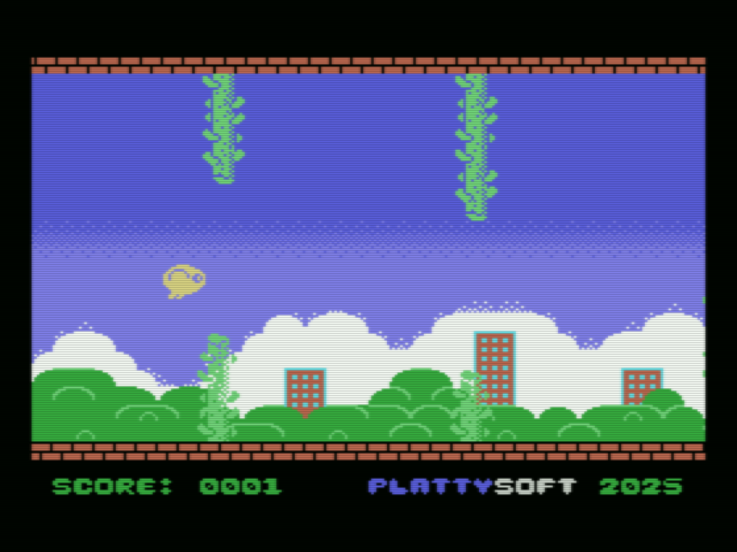

Gameplay
Your task is to help our winged hero to flap and struggle through the vine forest trying to get outside of the secluded valley.
You can press fire / space to jump. If you touch the floor, ceiling, or vines, you die.
That’s it, Patastratos are simple beings.

Afterword
Back in 2020 I somehow stumbled upon MSXPen and decided to see if I remembered my MSX Basic. I wanted a simple project, so I came up with this, and then I somehow convinced Ailantd to make the sprites. The game was unfinished for ages, while I moved into learning about MSX-Kun, Tiles, editors, etc…
4 games , 1 remaster, and 1 book later, I decided this game deserved to be finished. And because I wanted it to feel good, I decided it needed to run at 60 FPS.
So, here it is, Flappy Patastrato, the game that restarted my MSX Game Dev fever, finally out.

After Afterword
This game was obviously inspired by Flappy Bird. All subsequent nonsense about Patastratos is derived from our (Ailantd’s and mine) preexisting world building were Patastratos were already a thing.
Note: The vine forest might be infinite. There might be no escape. Don’t tell that to the Patastrato, they need to keep their hopes alive.
No Patastrato was harmed during the development of this game.

Credits
Sprites: Ailantd
Tiles, font and other graphics: Raul Portales
Music and SFX: Raul Portales
Coding: Also Raul Portales
Tools:
- openMSX
- Kate
- nMSXTiles
- TinySprite
- msxbas2rom
- MSXPen (originally)
- ArkosTracker 3

